**Ideation Phase**

**Define the Problem Statements**

|  |  |
| --- | --- |
| Date | 26 September 2022 |
| Team ID | 2609-1658478158 |
| Project Name | Real time Communication System Powered by AI for Specially Abled |
| Maximum Marks | 2 Marks |

**Customer Problem Statement Template:**

Create a problem statement to understand your customer's point of view. The Customer Problem Statement template helps you focus on what matters to create experiences people will love.

A well-articulated customer problem statement allows you and your team to find the ideal solution for the challenges your customers face. Throughout the process, you’ll also be able to empathize with your customers, which helps you better understand how they perceive your product or service.

Reference: <https://miro.com/templates/customer-problem-statement/>

**Example:**

|  |  |  |  |  |  |
| --- | --- | --- | --- | --- | --- |
| **Problem Statement (PS)** | **Iam (Customer)** | **I’m trying to** | **But** | **Because** | **Which makes me feel** |
| PS-1 | Person without disability | Communicate with deaf and dumb via phone | It is not possible | I can’t able to understand the sign language | Frustrated |
| PS-2 | Deaf and Dumb person | Communicate with normal person | I can’t able to hear what the normal person is trying to say | It finds difficult to response to a normal person with my sign language | So low and lone |

Problem Statement I:

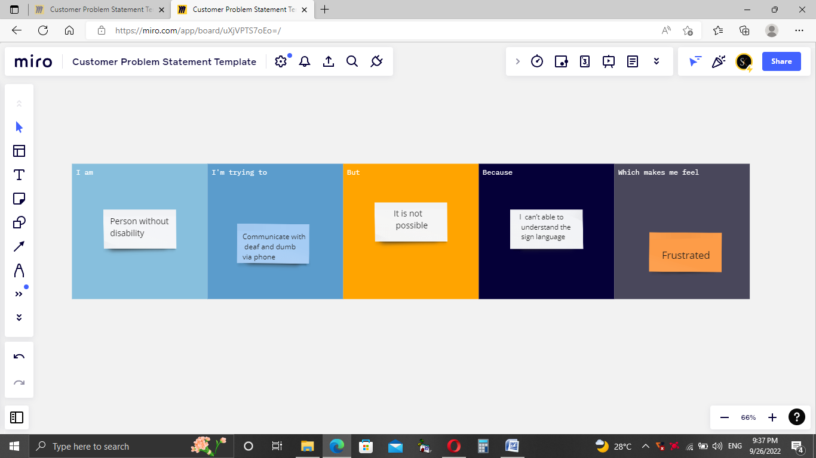

Problem Statement II:

